Mapping the distribution of the alien invasive Gracilaria vermiculophylla at the Site of its First European Introduction
Simon Oiry*
Bede Ffinian Rowe Davies¹
Valérie Stiger-Pouvreau
Pierre Gernez¹
Laurent Barillé¹

Abstract
The invasive red macroalga Gracilaria vermiculophylla has significantly impacted intertidal ecosystems in temperate estuaries globally. This study utilized drone-based multispectral remote sensing to map the spatial and temporal distribution of G. vermiculophylla in its first documented European site, the Bélon Estuary, alongside additional sites in Spain and France. By adapting the neural network classification model DISCOV, trained with a comprehensive dataset, we achieved 91.1% accuracy in distinguishing G. vermiculophylla from other macroalgal taxa. Historical aerial imagery revealed a progressive expansion of G. vermiculophylla from its initial appearance in 1976, approximately 20 years before its first description in the literature, to extensive colonization by 2024. Concurrent LiDAR data enabled precise characterization of intertidal topography, demonstrating a strong association between algal cover, elevation, and slope. Dense mats were consistently observed in flat, elevated mudflat areas, with reduced presence in steeper or lower zones. These patterns indicate that G. vermiculophylla is able to persist in stable, fine-sediment environments where hydrodynamic forces are relatively low. Temporal analyses also linked its spread to anthropogenic activities, notably aquaculture. Our findings emphasize the utility of high-resolution drone imaging for invasive species monitoring and habitat mapping, offering critical insights into the ecological dynamics of G. vermiculophylla and its drivers. This scalable method facilitates proactive management strategies by enabling early detection and detailed assessment of invasion patterns. The integration of remote sensing and in situ validation establishes a robust framework for ecological monitoring, contributing to the understanding of biological invasions and their environmental consequences. This approach can inform management interventions to mitigate the impacts of G. vermiculophylla and similar invasive species.

1. Introduction
The introduction of Non-Indigenous Species (NIS) in terrestrial, freshwater, and marine ecosystems is one of the major threats to biodiversity worldwide. In particular, the proliferation and rapid spread of Invasive Alien Species can radically change the structure and functioning of marine ecosystems, requiring effective assessment and monitoring programs (Massé et al., 2023). In Europe, 874 NIS have been introduced to the marine environment so far (i.e. until 2020) and it is expected that the rate of biological invasions will continue to increase in the coming years (Zenetos et al., 2022). Macroalgae account for over 40 % of the NIS introduced to Europe waters, with many species native to the Temperate Northern Pacific (Williams and Smith, 2007). They contribute between 20 - 29% of all marine NIS in the North-East Atlantic, Mediterranean Sea and Macaronesia, according to the study by Loos et al. (2024), who counted 418 NIS species in this region.
Amongst all invasive macroalgae, Gracilaria vermiculophylla (Papenfuss, 1967) (original name Gracilariopsis vermiculophylla (Ohmi, 1956); also known as Agarophyton vermiculophyllum (Gurgel et al., 2018)), has spread extensively from its native distribution range in Japan and Korea (Terada and Yamamoto, 2002). The rapid west-European expansion of G. vermiculophylla has been closely associated with movements of Pacific oyster (Crassostrea gigas) stock, a pathway identified by population-genetic and historical-shipment evidence (Krueger-Hadfield et al., 2017; Loos et al., 2024; Rueness, 2005; Weinberger et al., 2008).
In regions like the Baltic Sea and the eastern United States, it can affect native fucoid macroalgae and seagrasses negatively (Firth et al., 2024; Thomsen et al., 2013; Van Katwijk, 2003). It can also alter sediment composition (Nyberg et al., 2009), and disrupts trophic interactions (Ginneken et al., 2018). However, in soft-bottom areas where native habitat formers are lacking, dense mats of G. vermiculophylla can partially offset the loss of ecosystem functions—for example by creating refuge for invertebrates and juvenile fishes and by attenuating near-bed flow—although they do not provide the rhizome-mediated sediment stabilisation or long-term carbon storage typical of seagrass beds (Ramus et al., 2017; Davoult et al., 2017; Thomsen, 2010). The negative and positive effects of this species (Thomsen et al., 2009), which now dominate some coastal ecosystems, underscore the importance of monitoring and managing its population, particularly as climate change and anthropogenic pressures continue to facilitate biological invasions. G. vermiculophylla success as an invader stems from its tolerance to a wide range of environmental conditions, including temperature (Sotka et al., 2018), light (Surget et al., 2017), nutrient variability (Abreu et al., 2011), and salinity (Sotka et al., 2018; Weinberger et al., 2008). Its growth capacity at low salinities (Nyberg, 2007; Rueness, 2005) explains its presence in the brackish waters of the Baltic Sea (Weinberger et al., 2008) but also in the mesohaline sheltered part of estuaries of the Atlantic coast of Europe (Surget et al., 2017). It is also present in confined areas of lagoons characterized by low hydrodynamism (Abreu et al., 2011; Sfriso et al., 2012). In Europe, it was first observed in 1996 in the Belon estuary (France) and later in many other estuaries on the Brittany coast of France (Rueness, 2005). G. vermiculophylla can attach to biogenic structures that offer firm surfaces, such as polychaete reefs or mollusc shells (Kollars et al., 2016; Krueger-Hadfield et al., 2023; Thomsen et al., 2007), or to lithic substrates such as pebbles and rocks (Krueger-Hadfield, 2018; Nyberg et al., 2009; Terada and Yamamoto, 2002). However, its largest populations colonise estuarine intertidal mudflats as loose-lying mats on soft sediment, never attaching to biogenic structures as may be the case in other parts of the world and as described in Surget et al. (2017). In this habitat, extensive dark red mats are observed at low tide. Therefore, G. vermiculophylla can establish persistent populations in soft-sediment habitats where perennial macroalgal canopies are naturally sparse or seasonally absent (Ramus et al., 2017). These mats are usually monospecific in Sweden and France (Rueness, 2005; Surget et al., 2017), with the alga thalli partially buried in the mud, as observed in French populations. In germany however, Intertidal mats can be temporarily overgrown by ephemeral green macroalgae (Weinberger et al., 2008). In the European estuaries where G. vermiculophylla was first documented, large monospecific mats were reported to be confined to the upper intertidal zones (Rueness, 2005); however, their spatial distribution relative to the mudflat topography and elevation had not been quantitatively assessed. In coastal lagoons of the East Atlantic coast, Besterman et al. (2021) have shown that the mudflat topography was a significant predictor of its abundance. Recent drone surveys have delineated G. vermiculophylla mats using either (i) manual photointerpretation of orthomosaics or (ii) site-specific NDVI thresholds (Ross and Snyder, 2022). While informative, these techniques are difficult to transfer to new estuaries because both visual classification and NDVI break-points must be re-calibrated for local light, tide, and co-occurring algae. Thus basin-wide, standardised maps are still lacking (Abreu et al., 2011; Sfriso et al., 2012; Thomsen et al., 2007; Weinberger et al., 2008).
Remote sensing has revolutionized our ability to monitor and manage coastal ecosystems, offering efficient and scalable methods for detecting environmental changes in intertidal vegetation across a wide range of spatio-temporal scales (Calleja et al., 2017; Davies et al., 2024a, 2024b; Valle et al., 2015; Zoffoli et al., 2021). Among remote-sensing technologies, drone-based imagery has recently emerged as a particularly promising tool for studying the spatial distribution of intertidal primary producers such as benthic microalgae (Román et al., 2024, 2021), seagrass (Chand and Bollard, 2021; Duffy et al., 2018; Román et al., 2021) and macroalgae (Diruit et al., 2022; Peidro-Devesa et al., 2024). While it lacks the temporal consistency of satellite missions, drone remote sensing makes it possible to acquire at extremely high spatial resolution (i.e. cm-scale), rapidly target specific areas of interest, and provide observations in overcast conditions. In particular, the potential of drone remote sensing for monitoring the surface area occupied by Invasive Alien Species has been demonstrated (Roca et al., 2022). Drone-based photogrammetry also makes it possible to characterize the distribution of intertidal vegetation together with mudflat geomorphology, thus improving our understanding of primary producers patterning (Brunier et al., 2022; Douglas et al., 2024).
In this study we coupled centimetre-resolution drone imagery with complementary spatial data to resolve three outstanding objectives about the European invasion of Gracilaria vermiculophylla. First, an adapted version of the DISCOV convolutional network classifier (Oiry et al. 2024) is applied to drone mosaics from estuaries in France and Spain, providing the first transferable, high-accuracy maps of the alga's distribution along the Atlantic coast. Second, LiDAR-derived micro-topography is used to test whether those occurrences occupy a consistent “topographic window” of tidal elevation and surface flatness, thereby identifying the physical conditions that most favoured its establishment. Third, a time-series of aerial photographs dating back to the early 1950s was analysed to reconstruct the long-term expansion of G. vermiculophylla in its European bridgehead, the Bélon estuary, and to quantify changes in areal cover across seven decades. Together, these steps link centimeter-scale mapping to ecological mechanisms and invasion trajectory, advancing both drone-based remote sensing and our understanding of soft-sediment invasions by G. vermiculophylla, while also providing actionable information for management and policy.

2. Material & Methods

2.1 Study sites
Field campaigns were conducted at three study sites and four stations across France and Spain. At each site, two locations were investigated (Figure 1). The Aven & Belon estuaries in South Brittany, France (Figure 1 A & C) are dynamic ria-type systems hosting diverse habitats, including tidal flats and subtidal zones with coarse, marine-origin sediments (Castaing and Guilcher, 1995; Michel et al., 2021). These habitats support key benthic species such as Scrobicularia plana – the peppery furrow shell, an infaunal bivalve deposit-feeder; Cerastoderma edule – the common cockle, a suspension-feeding bivalve; and Tellina tenuis – the thin tellin, a small burrowing bivalve, all of which play essential roles in sediment bioturbation and nutrient cycling (Blanchet et al., 2014; Tankoua et al., 2011). These estuaries serve as a nursery for juvenile fish and a feeding ground for migratory birds, with their ecological productivity driven by a mix of euryhaline and marine species adapted to salinity gradients (Blanchet et al., 2014). Oyster farming, particularly Crassostrea gigas – the Pacific oyster, a large reef-building filter feeder (recent genetic studies have proposed reclassifying this species as Magallana gigas, but Crassostrea gigas remains widely used in environmental management literature), is a dominant activity, altering sediment dynamics and local biodiversity (Michel et al., 2021). Despite its ecological richness, the estuary faces pressures from nutrient loading and physical alteration (Tankoua et al., 2011).
The Saja-Besaya Estuary, situated along the Cantabrian Coast in northern Spain, is characterized by the confluence of the Saja and Besaya rivers near Torrelavega (Figure 1 C). The estuary, also known as San Martín de la Arena or Suances Estuary, has been subject to significant anthropogenic pressures, including industrial developments throughout the 20th century. These activities have led to contamination from mining, paper manufacturing, and carbonate discharges, classifying the estuary as highly polluted near its upper reaches (Ortega et al., 2005). This contamination impacted the water quality and biodiversity, with minimal aquatic life and sparse riverbank vegetation in its lower sections (Romero et al., 2008).
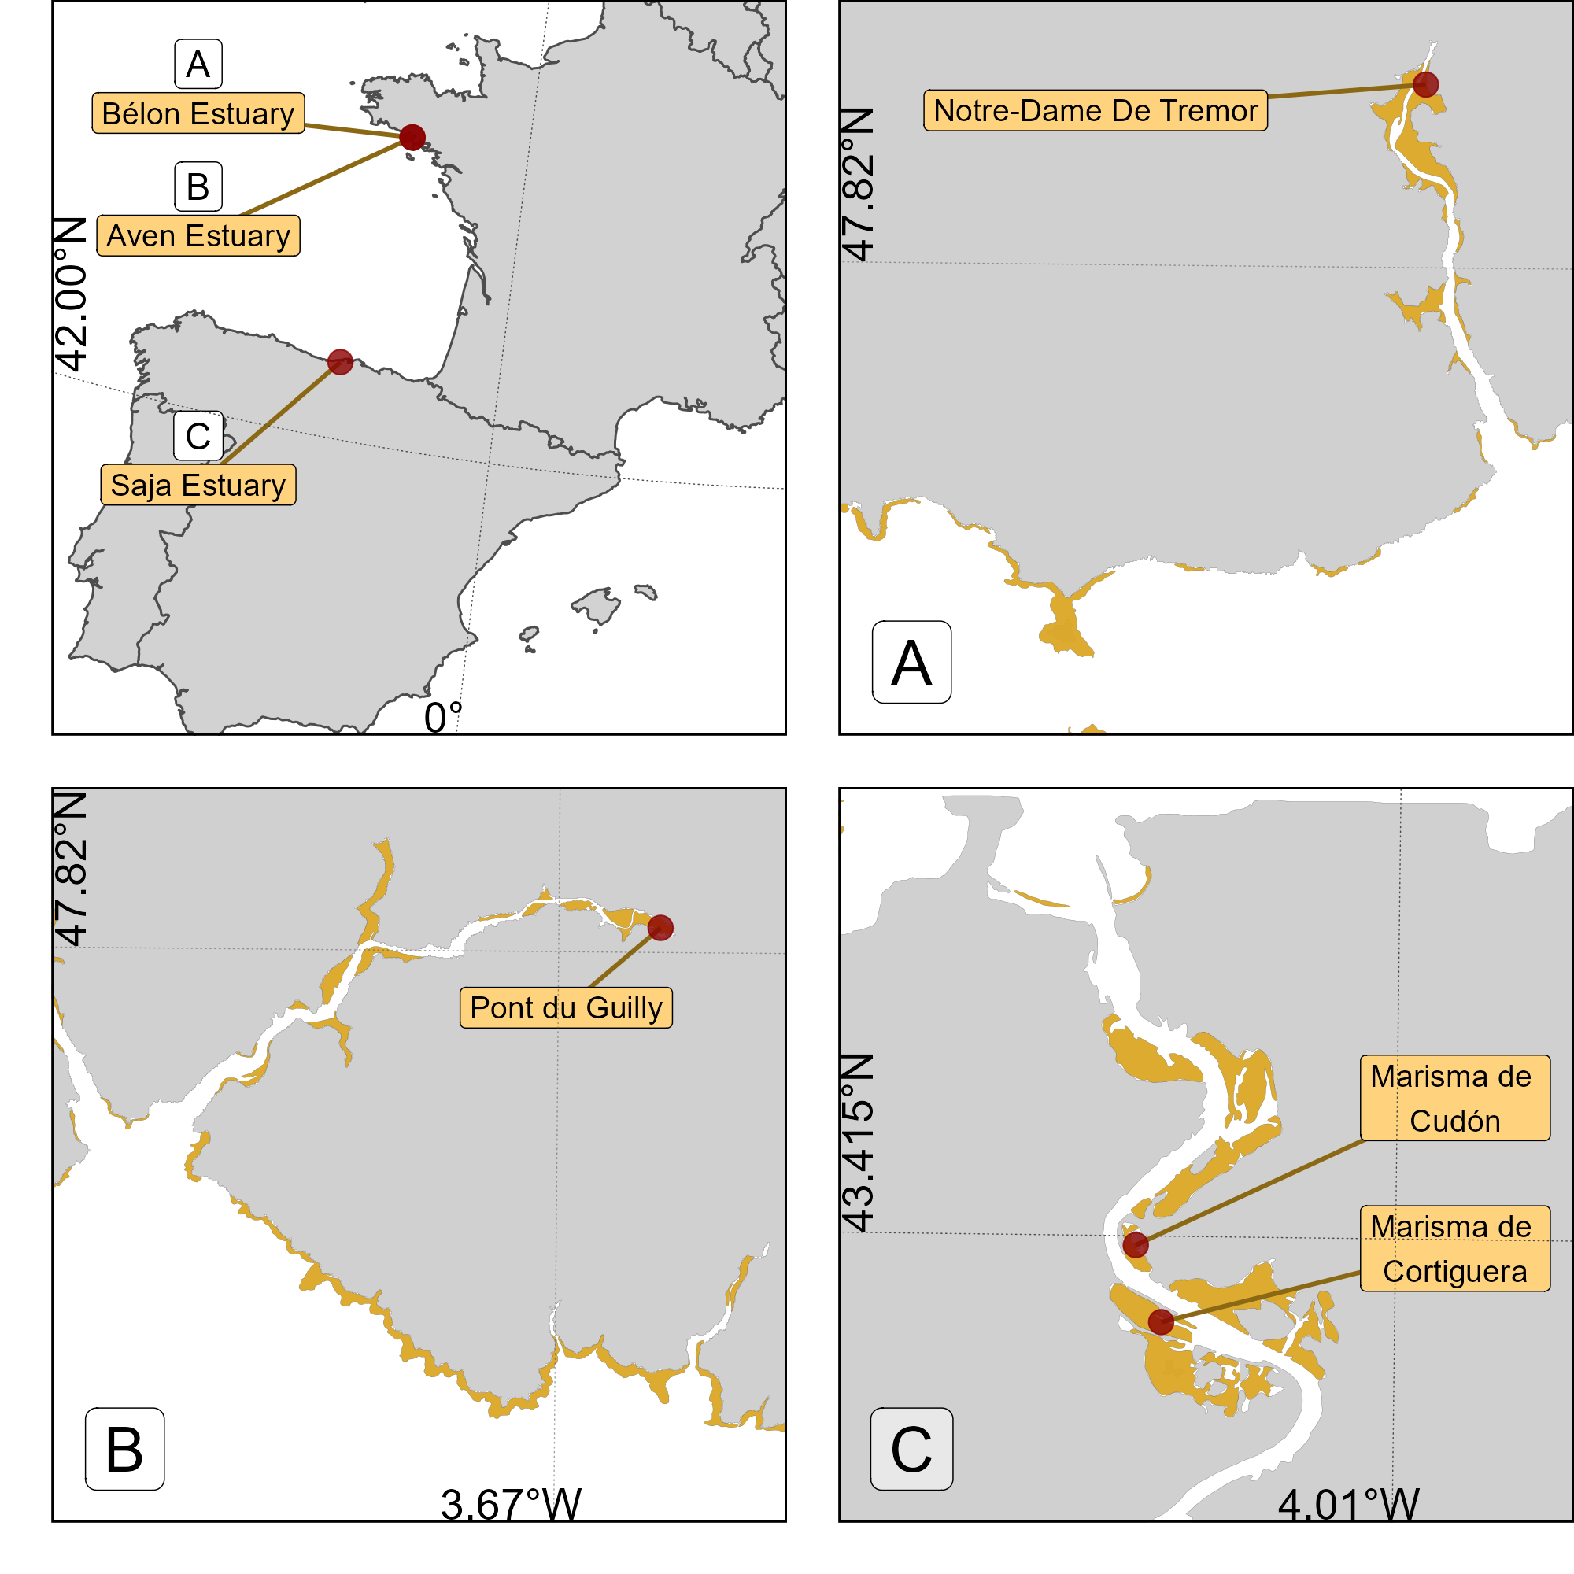
Figure 1: Location of the drone flights at the three study sites. A: Flights made in Aven Estuary, France; B: Flights made in Belon Estuary, France; C: Flights made at the two stations of the Saja Estuary, Spain. Golden polygons represent intertidal areas.

2.2 Remote sensing data acquisition and pre-processing
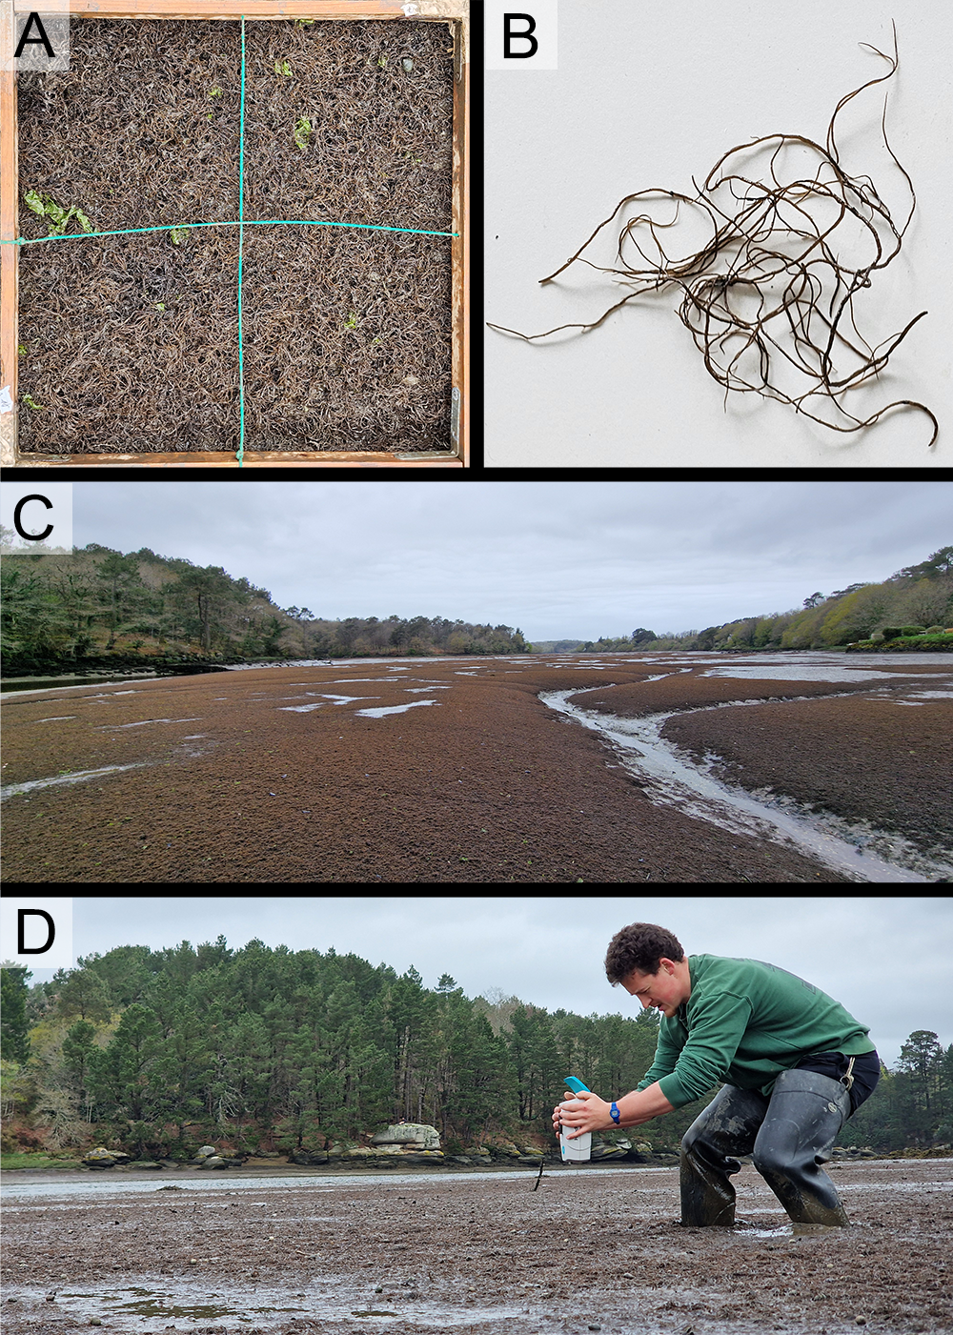
Figure 2: Gracilaria vermiculophylla in the Belon. A: Quadrat of 0.25 m² with a 100% cover of G. vermiculophylla; B: Single thallus showing cylindrical branches; C: Landscape view of mudflats covered by monospecific mats of G. vermiculophylla; D: Recording of the spectral signature of the algae using an ASD FieldSpec HandHeld 2 spectroradiometer.

2.2.1 Hyperspectral measurements
At each location, hyperspectral reflectance signatures were recorded using an ASD FieldSpec HandHeld 2 spectroradiometer (Malvern Panalytical, Worcestershire, UK), which measures reflectance from 325 to 1075 nm with a spectral resolution of approximately 1 nm (Figure 2 D). Each spectrum was subsequently smoothed using a Savitzky–Golay filter (Savitzky and Golay, 1964) with a third-order polynomial and an 11-point window, selected to minimize noise while preserving salient spectral features. After this initial smoothing, the first and second derivatives were computed using a central difference approximation (Equation 1).
$$f^{″\left(λ_{i}\right)}≈\frac{f\left(λ_{i+1}\right)-2f\left(λ_{i}\right)+f\left(λ_{i-1}\right)}{{\left(Δλ\right)}^{2}} \left(1\right)$$
where $f\left(λ_{i}\right)$ is the reflectance at wavelength $λ_{i}$ and $Δλ$ is the uniform spectral sampling interval.

2.2.2 Drone data
A total of four drone flights were conducted across the three study sites. All flights were performed at an altitude of 120 m and a speed of 10 m·s⁻¹. Two flights were carried out in the Saja Estuary on June 25, 2024, covering areas of 20.4 hectares (Marisma de Cortiguera) and 8.4 hectares (Marisma de Cudón), respectively (Figure 1). The other two flights took place in the Belon and Aven estuaries on April 11, 2024, covering areas of 21.3 hectares and 26.7 hectares, respectively.

2.2.2.1 Multispectral data
At each study site we flew a DJI Matrice 300 RTK fitted with a MicaSense RedEdge-MX Dual to capture 1.2-Mpx frames in ten spectral bands spanning the visible to NIR range (444, 475, 531, 560, 650, 668, 705, 717, 740, 840 nm). Flights followed a lawn-mower pattern whose tracks were oriented 90° to the solar azimuth, minimising glinting effects, and maintained 80 % forward and 70 % side overlap at 120 m of flight height, giving an 8 cm ground-sampling distance to the final orthomosaic. Before take-off and after landing a 50 % Spectralon® panel was photographed; together with a 2.5 Hz down-welling irradiance from the on-board DLS2 these images were used for an empirical-line calibration. Raw digital numbers were first corrected for dark current, row noise and vignette (manufacturer coefficients), converted to at-sensor radiance, and finally to surface reflectance by linear fitting to the panel reflectance for each band while compensating frame-to-frame irradiance fluctuations recorded by the DLS2. Images were processed in Agisoft Metashape v 2.0.3 (Agisoft, 2019) using a uniform template: sparse matching (40 000 key points · image⁻¹), tie-point filtering at a 1-pixel reprojection-error threshold, and bundle adjustment constrained solely by the real-time kinematic (RTK) positions embedded in each camera exposure (±1.6 cm XY, ±2.5 cm Z as specified by DJI). No ground-control points were collected. Dense-cloud generation (high quality), mild depth filtering and DSM-based true-orthorectification completed the workflow. Ortho-mosaics were exported in WGS 84 / UTM zone 30 N. Post-processing statistics indicate a mean reprojection error of 0.46 px (≈ 3.7 cm) and strip-alignment residuals < 2 cm, confirming sub-pixel planimetric accuracy across the mosaics despite the absence of ground control.
This identical radiometric and geometric pipeline was applied to every flight, ensuring that all 8 cm multispectral ortho-mosaics are radiometrically comparable and co-register to within one pixel, providing a consistent input for subsequent classification and ecological analysis.

2.2.2.2 LiDAR data
Using the Matrice 300 Series Dual Gimbal Connector, a DJI Zenmuse L1 LiDAR and RGB sensor was mounted on the drone alongside the multispectral camera. This setup enabled the simultaneous capture of LiDAR point clouds, high-resolution RGB images, and multispectral images collected by the MicaSense RedEdge Dual MX during the same flight. The same processing workflow as Section 2.2.2.1 was applied to process LiDAR RGB images, resulting in ortho-mosaic with a resolution of 2.5 cm per pixel. Since the mapping focused solely on surfaces without dense vegetation, the LiDAR measured only a single return. Operating in repetitive scanning mode with a sampling rate of 240 kHz, the system achieved a point density of 350 points per square meter. The LiDAR point cloud was extracted and converted into LAS format using DJI Terra software. The LAS point cloud was then imported into Agisoft Metashape (Agisoft, 2019) to generate a Digital Surface Model (DSM) with a resolution of 2.5 cm. From the DSM, the slope of each pixel based on a grid of 8 surrounding pixels was computed using the terrain function of the ‘terra’ package in R (Hijmans, 2024). The angle of the mudflat was categorized into three classes: Flat (angle < 10°), Angled (10° ≤ angle ≤ 40°), and Steep (angle > 40°).

2.3 Scene classification
In a previous study we developed a neural-network classification model (DISCOV; Oiry et al. (2024)) — a feed-forward fastai network with two hidden layers, 26 054 trainable parameters, and 21 spectral predictors (10 raw MicaSense bands, their min-max-scaled counterparts, and NDVI) that was trained for 12 epochs to classify 5 classes of intertidal vegetation. The same model, already shown to map intertidal vegetation along the Portuguese and French Atlantic coasts with >94 % overall accuracy and κ = 0.92 on an independent set of ≈536 000 pixels, is used here. The training dataset of DISCOV v1.0 (418 164 photo-interpreted pixels at 8 mm resolution across seven habitat classes) contained only 5 771 Florideophyceae pixels (3 %). To fill this gap, we updated the dataset with new training pixels from the five additional drone flights (Section 2.2), adding 427000 pixels (Section 6.1), following the methodology presented by Oiry et al. (2024).
To validate the DISCOV model, a user-friendly Shiny app was developed. This app enabled independent users to photo-interpret snapshots of the ortho-mosaic from each drone flight (Chang et al., 2024; Oiry, 2024). Users could click on various parts of the snapshots to indicate the type of vegetation they believed was present. Using this method, 3 independent users contributed to creating a validation dataset of 6755 pixels across 79 snapshots distributed among the four drone flights (Section 6.2). The validation dataset was then simplified into two classes: The presence or absence of red algae (Figure 3).
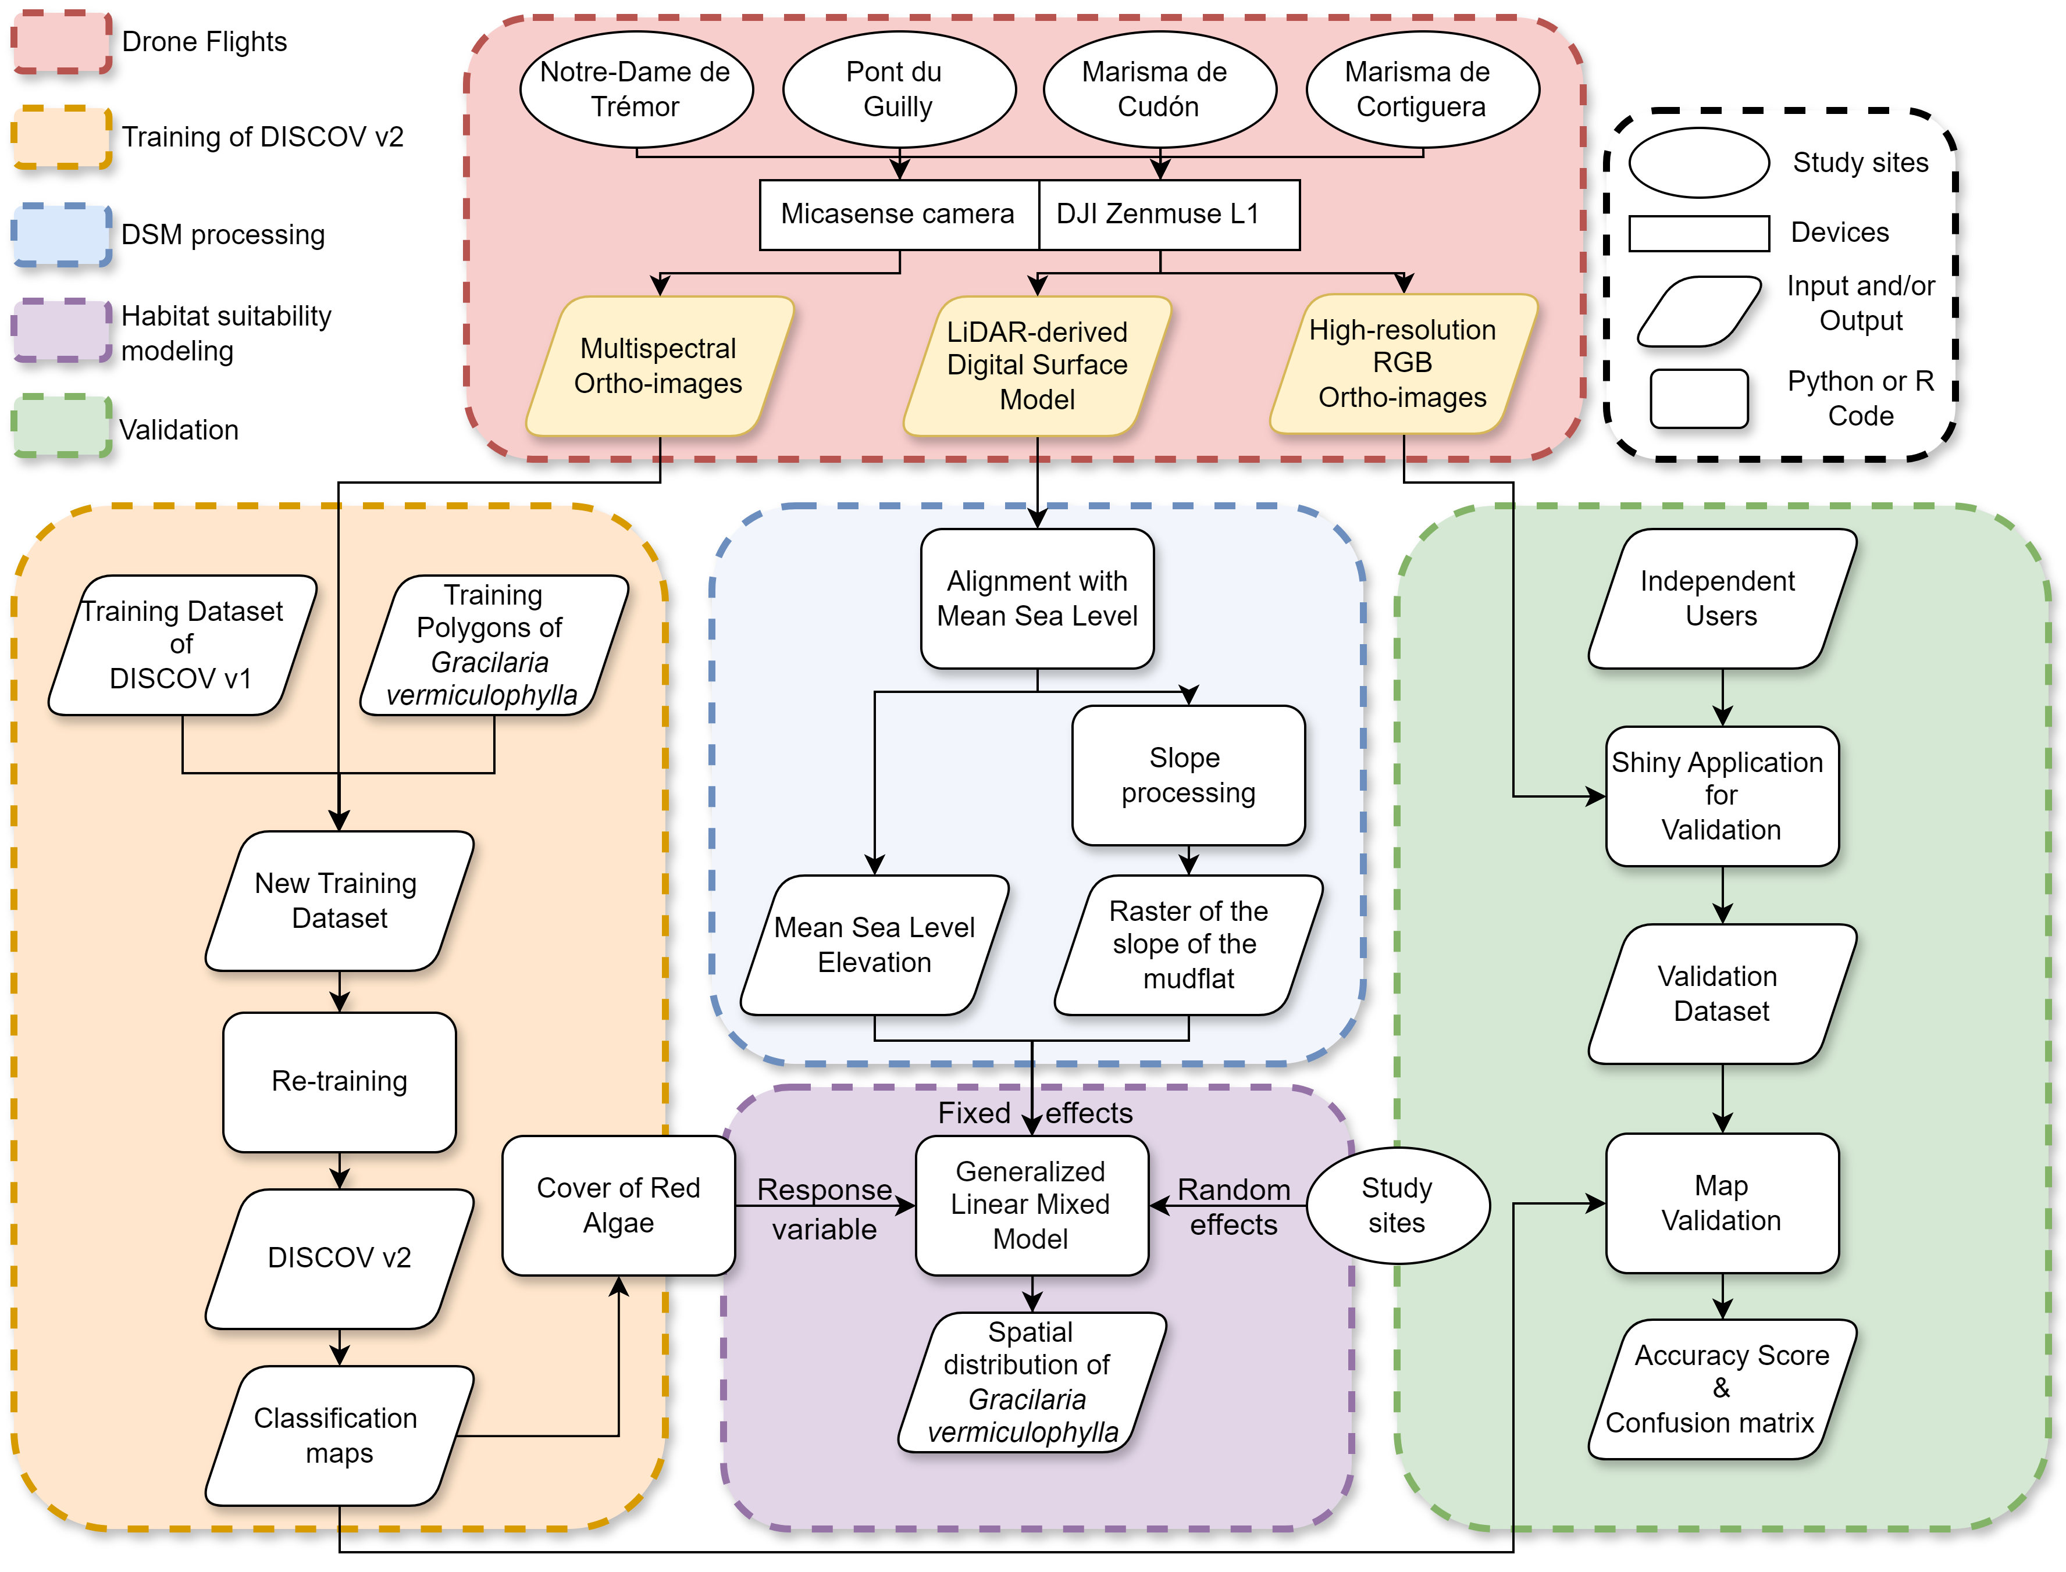
Figure 3: Schematic representation of the workflow. Parallelograms represent input or output data, rectangles represent Python processing algorithms, long rectangle represent instruments used and ovals represent study sites. Red shows Drone data; Orange shows the model training; Blue shows processing performed on the Digital Surface Model; Green shows the validation of the model; Purple shows the statistical analysis.

2.4 Historical Presence of Gracilaria vermiculophylla in the Bélon estuary
To assess the historical presence of G. vermiculophylla in the Belon Estuary, aerial imagery from flight campaigns was obtained via the IGN platform “Remonter Le Temps” (IGN, 2024). Nine images were selected between 1952 and 2012 from the IGN platform and an additional one has been added for the year 2024 (Section 6.3). Since most of the images retrieved from “Remonter Le Temps” were digitized versions of physical photographs, georeferencing was required.
For each date, polygons have been drawn around G. vermiculophylla patches by visual photo-interpretation. These polygons were used to calculate the total area of the mudflat covered by macroalgae within a common extent of 30 hectares in Pont de Guilly, located in the Belon Estuary, South Brittany, France.

2.5 Statistical analysis
We used a Generalized Linear Mixed Model (GLMM) within a Bayesian framework using the ‘brms’ package in R (Bürkner, 2021, 2018, 2017). The response variable, the cover of G. vermiculophylla (Cover), was modeled using a Beta distribution as a function of bathymetry elevation (Bathy) and the angle of the mudflat (Angle ; categorized as Flat, Angled, Steep). A random intercept for site (Site) was included to account for potential hierarchical variation among sampling sites (Equation 2). The Beta distribution was chosen because the response variable is continuous and constrained between 0 and 1. The response variable was modeled assuming a beta distribution, with flat priors. Model parameters were estimated using Markov Chain Monte Carlo (MCMC) sampling, with 4 chains of 5000 iterations and a warm-up (i.e. burn-in) of 500. Convergence and sampling quality were verified by inspecting the Gelman–Rubin statistic (Rhat ≤ 1.01 for every parameter) together with bulk and tail effective sample sizes (all > 1 000), confirming that the posterior was thoroughly explored and free of divergent transitions.

$${Cover}_{i} \sim Beta\left(μ_{i}ϕ,\left(1-μ_{i}\right)ϕ\right) \\ μ_{i}=logit\left(η_{i}\right) \left(2\right) \\ η_{i}= α_{{Site}_{i}}+ β_{1}{Bathy}_{i}+β_{2}{Angle}_{i} \\ α_{{Site}_{i}} \sim Student\left(\overline{α}, δ\right) \\ \overline{α }\sim Student\left(3, 0, 2.5\right) \\ δ \sim Student\left(3, 0, 2.5\right) \\ ϕ \sim Gamma(0.01, 0.01)$$

3. Results

3.1 Historical records in the Belon estuary
A clear shift from bare sediment to vegetated mudflats has been observed over the past 70 years, corresponding to the colonization of the Belon Estuary by G. vermiculophylla (Figure 4). In the 1950s, the tidal flats showed no detectable presence of vegetation. In the 1970s some darkening of the sediment became discernible, but the first unambiguous presence of G. vermiculophylla was 1982. During the subsequent decades, the cover of algae increased and in 2024, the high-resolution mapping done with the drone showed that monospecific mats of G. vermiculophylla exclusively colonised the mudflat.
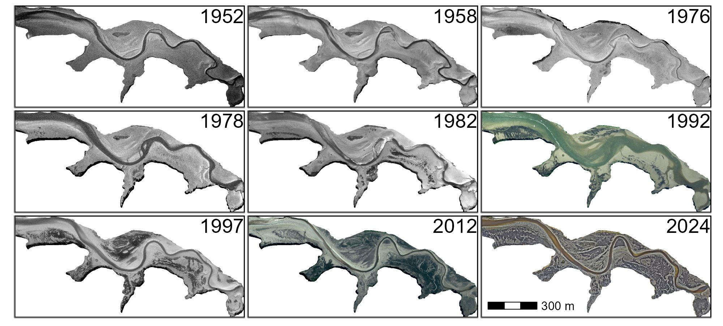
Figure 4: RGB images of the Belon Estuary (Pont de Guilly) showing the colonization of the mudflat by Gracilaria vermiculophylla between 1952 and 2024. Red algae appear as dark patches on the mudflat.
From the early recordings in the 1950s through the late 1970s, Gracilaria vermiculophylla coverage remained effectively at 0% (Figure 5). Shortly after the introduction of Crassostrea gigas in the estuary, in 1971-1972 (see vertical red dashed line in the figure), the first detectable presence of G. vermiculophylla emerged. By 1976, it covered 2.5% (0.7 ha) of the Pont du Guilly area, and by 1978 it had increased slightly to 3.0% (0.9 ha). From 1982 onward, coverage expanded more rapidly, increasing from 6.6% (2.0 ha) in 1982 to 14.7% (4.5 ha) in 1992 and nearly 30% (9.0 ha) by 1997. This upward trend continued into the 21st century, peaking at 41.2% (13.3 ha) in 2012. Although coverage fluctuated somewhat thereafter (40.6% in 2019 and 41.8% in 2024), it remained consistently high, indicating sustained and widespread colonization.
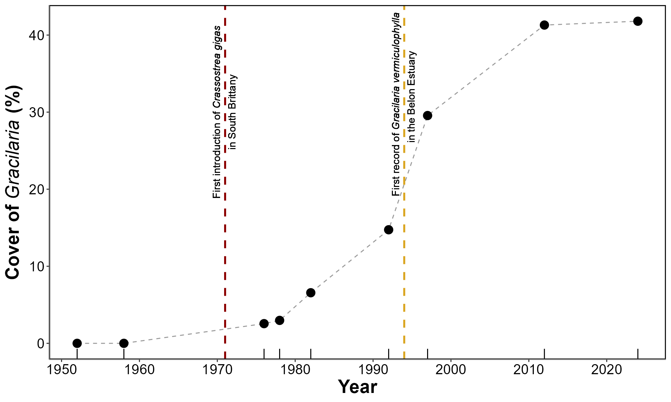
Figure 5: Trend of the Gracilaria vermiculophylla cover in the Belon Estuary (at Pont du Guilly). The red vertical line indicates the date of Crassostrea gigas introduction in South Brittany (Grizel and Heral, 1991), while the golden line represents the date of the first documented mention of Gracilaria vermiculophylla presence in Europe which was in the Belon Esturay (Rueness, 2005).

3.2 Spectral description
The spectral signature of G. vermiculophylla was characterized by a reflectance pattern in the visible region of the spectrum shaped by the photosynthetic and accessory pigments common to all red algae (Figure 6 A). This pattern was primarily driven by phycoerythrin and phycocyanin, which exhibited maximum absorption peaks at approximately 565 nm and 620 nm, respectively. An additional absorption feature around 495 nm was likely attributable to accessory carotenoid pigments. The most pronounced absorption peak occurred at 675 nm, corresponding to chlorophyll-a absorption. The second derivative analysis clearly highlighted the inflection points corresponding to the main absorption peaks at 495, 565, 620, and 675 nm, allowing for more precise identification of the wavelength associated with these pigments (Figure 6 B).
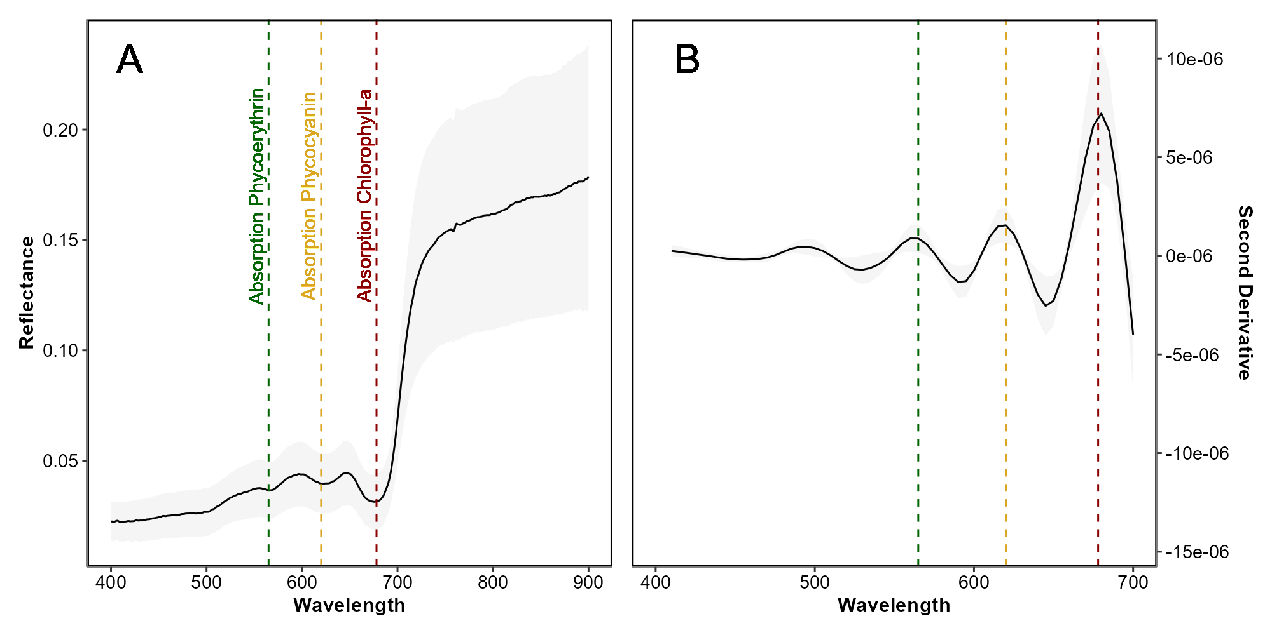
Figure 6: Hyperspectral signature of Gracilaria vermiculophylla (A) and its second derivative (B). The black line represents the average spectra, while the shaded area indicates the standard deviation. Dashed lines mark the absorption maxima of Phycoerythrin, Phycocyanin, and Chlorophyll-a, shown in green, orange, and red, respectively.

3.3 Spatial distribution
The classification map obtained from the neural network algorithm is shown for the Belon estuary (Figure 7 A). Among the main classes of the intertidal vegetation, the class of Florideophyceae (red macroalgae, in red) was the dominant algal cover, forming extensive, continous patches colonizing almost the entire mudflat. In contrast, Bacillariophyceae (diatoms biofilm, in orange) and Chlorophyceae (Green macroalgae, in green) exhibited more localized distributions, typically restricted to smaller, fragmented patches. A few Phaeophyceae (brown macroalgae, in brown) were confined to limited patches in the upper intertidal attached to rocks. In the Saja esturay, Florideophyceae cover was more scarsed, due to a strong Chlorophyceae presence on this site (Annexe D: Section 6.4).
Across the study sites the presence/absence of G. vermiculophylla was classified with a global accuracy of 91.1 %, a sensitivity of 96.5 %, a specificity of 71.5 % and an F1 score of 94.4 %.
The elevation map showed that the main mats of G. vermiculophylla were between 1 and 2 m above mean sea level (Figure 7 C). Algal presence was markedly elevation-driven, with lower intertidal zones closer to the tidal channel consistently exibiting reduced macroalgal cover. Most of the intertidal flats exibited slope below 10° (Violet, (Figure 7 D). Angled surfaces (10° < Slope < 40°) often found next to tidal channels were exibiting almost no vegetation cover.
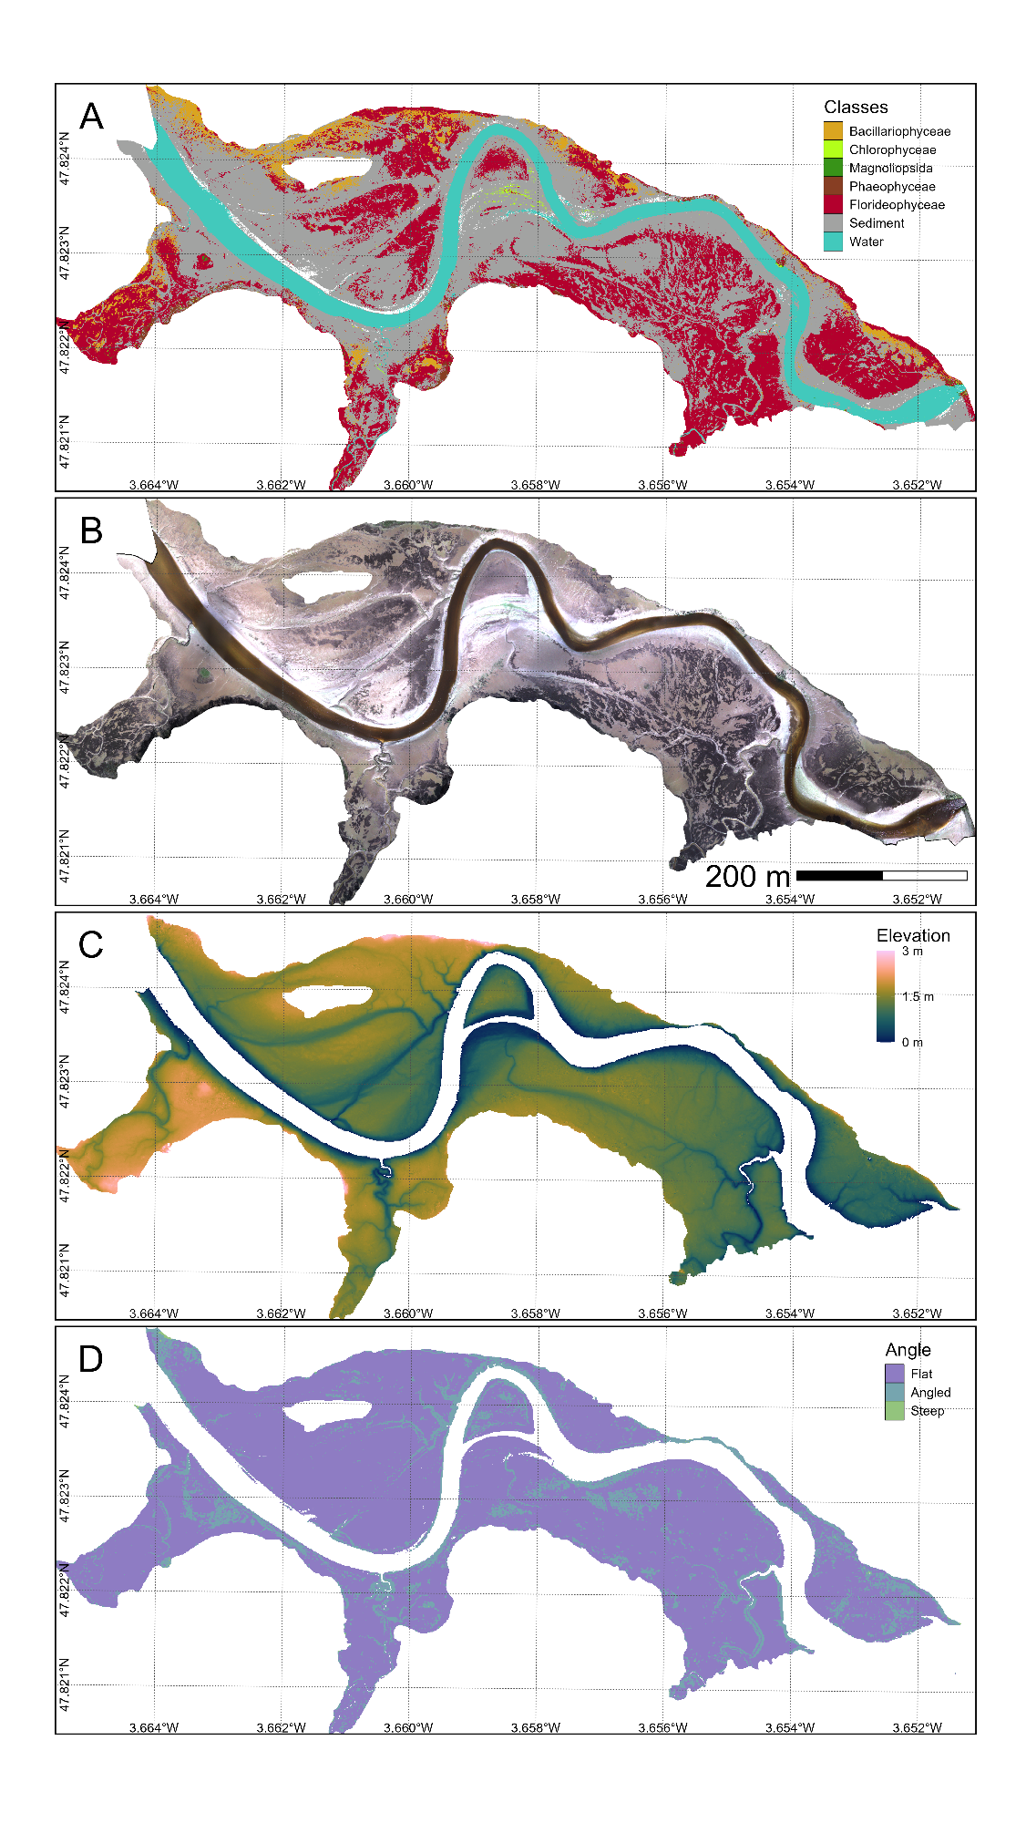
Figure 7: Classification of the main classes of intertidal vegetation with a neural network algorithm (A), RGB composition (B), Elevation (C) and mudflat topography (D) of the Belon estuary site in Brittany, France. This flight was done on April 2024 and covers 21 hectares with a resolution of 80 mm per pixel. Elevation corresponds to the height above mean sea level.
Overall, the percent cover of G. vermiculophylla increased with elevation, as shown by the general relationship (Figure 8, black line), which rises from approximately 16% at the lowest elevation to about 30% at the highest elevation. This indicates a consistent positive association between elevation and algal cover.
When accounting for slope, the flatter the slope, the higher the percent cover of G. vermiculophylla. For flat slopes, the cover ranged from approximately 20% at the lowest elevation to nearly 38% at the highest elevation. In contrast, the increase was less pronounced for angled slopes, ranging from around 16% to 32%. The cover was the lowest on steep slopes, starting at about 15% and rising only slightly above 30% at the highest elevation (Figure 8). This demonstrates that slope modifies the relationship, with flatter slopes supporting a greater percent cover of the algae.
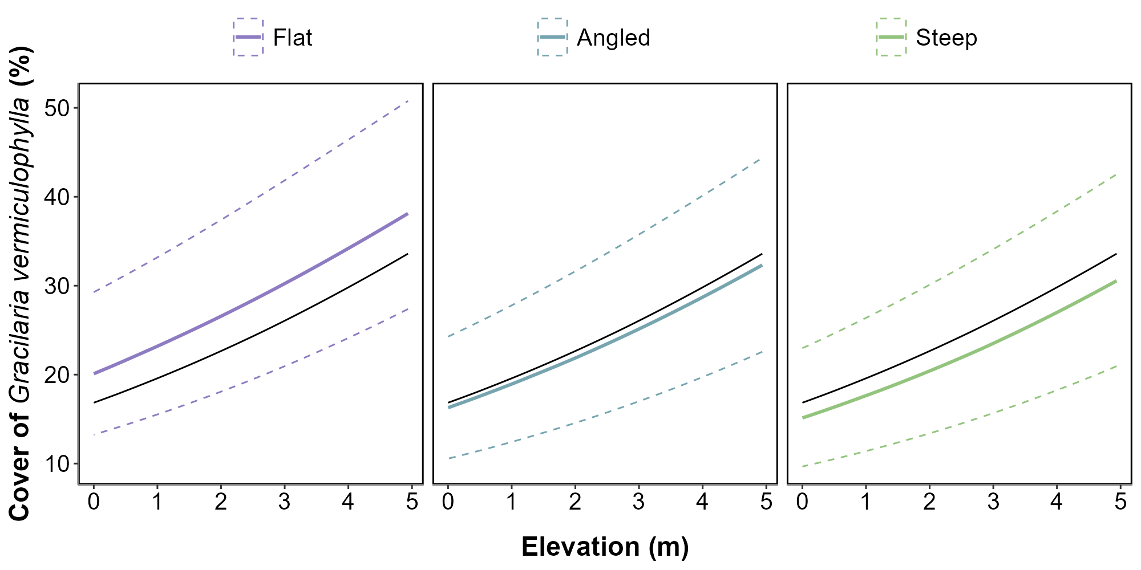
Figure 8: Relation between the elevation (in meters) and the percentage cover of Gracilaria vermiculophylla across three slope categories: Flat, Angled, and Steep. Solid lines represent fitted generalized linear model predictions, with dashed lines indicating 89% confidence intervals. The solid black line represents the mean predicted coverage across all slope categories.

4. Discussion

4.1 Drone mapping G. vermiculophylla with machine learning
In this study, we produced the first spatial distribution maps of the invasive red macroalgae Gracilaria vermiculophylla using a multispectral drone survey conducted at low tide in Atlantic estuaries representing varied environmental conditions. The species formed monospecific mats in southern Brittany, while in the Cantabrian region of Spain, it was mixed with other intertidal vegetation. Distinguishing among these vegetation types was a key prerequisite for the analysis. To achieve this, we developed a new version of the deep learning-based classification model DISCOV initially developed to discriminate seagrass from green macrophytes (DISCOV ; Oiry et al. 2024). DISCOV v2.0 was based on an improved training dataset, which included a larger number of pixels on red macroalgae covering approximately 26 % of one million pixels and allowed the model to achieve an accuracy of 91.1 % in predicting G. vermiculophylla presence.
Red seaweeds possess unique phycobilin pigments, enabling their spectral distinction from other macroalgal groups (Douay et al., 2022; Mcilwaine et al., 2019; Olmedo-Masat et al., 2020). Even with the ten-band multispectral sensor used in our study, it remained feasible to discriminate the major classes of intertidal macrophytes (Davies et al., 2023; Oiry et al., 2024; Román et al., 2021). Note that DISCOV V2.0 identifies G. vermiculophylla at the class level (Florideophyceae) rather than at the species level. Although it is unlikely that Gracilaria can be precisely distinguished at the species level using standard multispectral, hyperspectral data may allow mapping on a finer taxonomic resolution (Douay et al., 2022; Olmedo-Masat et al., 2020). Ecological factors also contribute to distinguishing G. vermiculophylla. Macroalgae require hard substrates for the spores to settle, but some Gracilariales species can establish on soft-bottom sediments. G. vermiculophylla is found on mudflats, anchoring its thalli in the top 10 cm of mud (Surget, 2017), and inhabiting the upper intertidal zone of estuaries in Western Europe—an unusual trait for a red seaweed (Abreu et al., 2011; Davoult et al., 2017). By effectively detecting G. vermiculophylla in these soft-sediment environments, the methodology developed in this study provides a framework for mapping this species in coastal areas. A multispectral sensor is necessary to obtain spatially explicit maps when this species is mixed with other classes of intertidal vegetation. However, when monospecific mats are the primary vegetation colonising tidal flats, RGB drone imagery can be exploited.

4.2 G. vermiculophylla spatial distribution and mudflat topography
The The spatial distribution of G. vermiculophylla across intertidal zones of West European estuaries revealed a relationship with mudflat topography, significantly influencing algal abundance. Our results showed that higher elevations within the intertidal zone supported a greater abundance of G. vermiculophylla. Thomsen et al. (2009) observed this species inhabiting areas as elevated as the mudflat-marsh border. This capacity to colonise the upper intertidal is related to its broad stress tolerance under variable light, salinity, and grazing conditions (Thomsen et al., 2007). Its capacity for sustained growth under desiccation, light and salinity extremes (Nyberg, 2007; Raikar et al., 2001; Rueness, 2005) explains its successful establishment at high elevations in mesohaline estuarine environments (Weinberger et al., 2008). Longer aerial exposure at these elevations is partly offset by the species’ exceptional tolerance of dehydration (survival after>5 months dark storage at 8 °C) and its ability to re-hydrate rapidly once inundated, so that net photosynthesis remains positive during most tidal cycles (Hu and Juan, 2014). In the Belon estuary, most of G. vermiculophylla was found between 1 and 2 m above MSL, which are high elevations for which rapid desiccation of this macroalgae was described by Thomsen and McGlathery (2007) in shallow lagoons of the Eastern Atlantic coast. The thick mat structure observed in Western Europe may explain this discrepancy by retaining more water. These mats also trap suspended sediments and organic detritus, progressively raising the bed and creating the soft, nutrient-rich substratum on which new thalli can attach—an example of positive niche construction (Byers et al., 2012). A lower hydrodynamism also characterizes these areas. Unlike seagrasses—marine angiosperms that colonize soft sediments using rhizomes for robust anchorage—G. vermiculophylla, lacks such specialised structures, and reproduces vegetatively by fragmentation of the thallus. Consequently, it is more vulnerable to disturbance and displacement by waves and tidal currents than seagrass. Micro-topographic depressions formed by low slopes (< 1.5°) reduce drag forces during ebb–flow reversals and act as “fragment traps”, favouring the retention of drifting thalli that seed new patches (Byers et al., 2012). In the estuaries of South Brittany, this species can bury part of its thalli into the upper layers of soft sediment (Surget, 2017). This mode of anchorage likely helps G. vermiculophylla withstand strong currents or wave action and contributes to forming these thick mats. The creation of such mats probably also requires areas with high sedimentation rates, typically found in the upper intertidal or the vicinity of marshes, promoting sediment deposition (Mudd et al., 2010). This observation aligns with the findings illustrated in Figure 4, which show that one of the first areas colonized by G. vermiculophylla in the Belon estuary was located near a salt marsh patch. These dense mats enhance its stability and facilitate its persistence and proliferation in intertidal and estuarine environments with low to moderate hydrodynamic conditions (Surget, 2017).
There was a significant negative relationship between slope steepness and the density of G. vermiculophylla. Besterman et al. (2021) showed that mudflat topography was a good predictor of G. vermiculophylla abundance, while Thomsen et al. (2009) reported a high abundance in marshes with low slopes. Mudflat topography integrates several flow-related variables (Besterman et al., 2021). Steeper slopes are typically associated with higher current velocities during tidal exchanges, resulting in stronger erosion and reduced sedimentation. Under such conditions unattached thalli are more readily exported and the probability of successful re-attachment drops sharply. Areas with steeper slopes may also limit the retention of organic matter and nutrients, reducing the availability of essential resources needed for algal growth. In contrast, flatter areas within the intertidal zone (slikke) are more likely to accumulate fine sediments and retain water for longer durations during low tides, creating a more stable and nutrient-rich environment conducive to G. vermiculophylla proliferation. These low-slope conditions may also favour dense algal mat formation, further stabilising the sediment and promoting growth.

4.3 Monitoring Gracilaria vermiculophylla Invasion Dynamics
The invasive red macroalga G. vermiculophylla represents a significant example of delayed recognition and documentation in biological invasions. Historical aerial imagery and photo-interpretation analyses from the Belon Estuary suggest the initial presence of this species in 1976 (Figure 4), preceding its first formal description in European waters in 1996 by two decades (Rueness, 2005). This delay likely stems from insufficient early monitoring frameworks and limited awareness of its ecological impacts, which often characterize the early stages of invasive species colonization. It also arises from the fact that other red macroalgae species resembling G. vermiculophylla and native to this area (e.g. Gracilaria gracilis) were already present at sites where G. vermiculophylla was introduced, further complicating its detection. This lag highlights challenges associated with detecting, monitoring, and reporting invasive species and their ecological impacts during early colonization.
The appearance of G. vermiculophylla corresponds with the introduction of the Pacific oyster (Crassostrea gigas) into the estuary a few years before, between 1971 and 1975, and a potential vector for algal dispersal through aquaculture activities (Grizel and Heral, 1991; Rueness, 2005). Aquaculture operations such as the movement of spat bags, grow-out nets, and shell‐hash clutch, can unintentionally transfer small fragments of G. vermiculophylla. Such fouled materials, rather than live oyster shells per se, are considered the main vector that introduced the alga to several European lagoons, including its first Mediterranean record in 2008 (Loos et al., 2024). In Brittany the first aerial detection of the alga in 1976 occurred four years after large-scale oyster transfers began in the Bélon and Aven estuaries (Grizel and Heral, 1991), suggesting oyster culture as a probable—though not exclusive—vector. After initial establishment, the alga progressively occupied suitable habitats, consistent with theoretical invasion dynamics involving a lag phase followed by rapid spread (Arim et al., 2006). The establishment of G. vermiculophylla likely induced changes in sediment characteristics, trophic interactions, and habitat structure prior to formal recognition (BenDor and Metcalf, 2006). Such shifts are comparable to documented impacts in similar systems (Crowl et al., 2008; Gallardo et al., 2016), yet remain difficult to quantify without early monitoring data. Remote sensing using multispectral drone mapping can provide high-resolution, spatially explicit data, but it must be combined with repeated, in situ field measurements to maximize its potential (Chadwick et al., 2020; Zoffoli et al., 2023). Temporal repetition makes it possible to assess dynamic processes, and integrating these mapping approaches with in situ analyses of local infauna, carbon cycling, riverine inputs, and sedimentology yields valuable data for local managers. Such an integrated approach can determine how the invasive algae affects the local ecosystem and, more broadly, forecast its potential impact on other estuarine environments facing similar invasion events.
The temporal gap between the first presence and documentation reflects limitations in early surveillance, potentially underestimating ecological and economic impacts during the initial colonization phase. Studies on invasion dynamics demonstrate that early detection is crucial for effective containment and management, particularly before an invasion reaches the exponential spread phase, which complicates control efforts (Arim et al., 2006; BenDor and Metcalf, 2006; Elton, 2020). Specific practices, such as the removal of early-stage algal mats, implementation of physical barriers to prevent further spread, and public awareness campaigns, could mitigate the impacts during this critical phase (Green and Grosholz, 2021; Jones et al., 2021; Simberloff, 2021). In the Belon Estuary, G. vermiculophylla appears to have thrived under ecological conditions favorable to its proliferation, enabling the formation of dense mats in about 6 years (between 1976 and 1982; Figure 4) after its first detection in the estuary. This undocumented growth likely contributed to substantial changes in the estuarine ecosystem. Historical aerial imagery has provided valuable insights into long-term invasion patterns by enabling the retrospective identification of shifts in habitat characteristics. Modern drone-based systems enhance this capacity through high spatial and temporal resolution, enabling the rapid detection of invasive species at early stages of establishment. Remote sensing facilitates timely interventions by capturing detailed data on the spatial distribution and habitat preferences of species such as G. vermiculophylla, allowing stakeholders to take rapid measures to limit the invasion. Integrating these tools into routine monitoring programs offers a scalable and efficient means to track invasive species dynamics and inform targeted management strategies, such as habitat restoration, removal of invasive mats, and prevention of further spread through targeted interventions. Expanding these methodologies to lower-cost RGB-based detection would further democratize access to monitoring tools, enabling more widespread application for early detection and rapid response. These tools could also be integrated into community-driven management programs, empowering local stakeholders to monitor invasive species and implement timely control measures.
5. Conclusion
This study demonstrated the potential of high-resolution drone-based multispectral remote sensing to map the spatial and temporal distribution of the invasive red macroalga G. vermiculophylla in European estuaries. By employing the DISCOV machine-learning model, updated to include an extensive dataset of Florideophyceae pixels, we achieved a classification accuracy of 91.1%. Our analysis revealed a clear spatial relationship between G. vermiculophylla and intertidal topography retrieved from LiDAR, with its cover consistently higher in flat, elevated mudflats compared to lower and steeper areas. The temporal progression, derived from a historical dataset spanning over seven decades, highlights the progressive establishment and expansion of the algae. Notably, our remote sensing analysis confirmed the presence of G. vermiculophylla in the Belon Estuary approximately 20 years before its first scientific description, emphasizing the value of retrospective mapping. The historical aerial imagery analysis provided crucial insights into the dynamics of G. vermiculophylla’s invasion, revealing a lag phase followed by rapid colonization, as it is observed in all introduced species (Stiger-Pouvreau and Thouzeau, 2015). This expansion coincided with the development of Pacific oyster aquaculture, suggesting oyster as a potential vector of dispersal of this invasive species. These findings underscore the crucial role of remote sensing in ecological research, particularly in studying invasive species (Roca et al., 2022). Integrating hyperspectral sensors could enhance species-level discrimination while adopting low-cost RGB-based methods could extend monitoring capacities to a broader range of stakeholders. The larger mats could be detected at a coarser spatial resolution, and a perspective of this work is to use Sentinel 2 satellite images at a 10 m resolution (Davies et al., 2024b). These advancements will be crucial for informing management strategies, fostering community engagement, and preserving estuarine biodiversity in the face of ongoing ecological changes.

6. Acknowledgement

This work has been found by the French Space Agency (CNES) through the project INVASEA (grant number: 24035/00).

6. Annexes

6.1 Annexes A - Updated training dataset
Table 1: Class of the Neural Network model, with the number of training pixels used to train that class and the differences with the training dataset of DISCOV v1.0
Name | Taxonomic Unit | Training Pixels | Difference with DISCOV v1.0
Benthic Diatoms | Bacillariophyceae | 62,436 | x13.95
Green macroalgae | Chlorophyceae | 92,585 | x5.4
Seagrass | Magnoliopsida | 221,065 | -
Brown macroalgae | Phaeophyceae | 169,936 | -
Red macroalgae | Florideophyceae | 268,637 | x46.55
Sediment | - | 117,956 | x1.24
Water | - | 91,614 | x1.09

6.2 Annexes B - Validation dataset
Table 2: Presence and absence of red macroalgae for each drone flight. Values indicate the number of pixels.
country | Site | Absent | Present | Total
Spain | Marisma de Cortiguera | 1,531 | 483 | 2,014
Spain | Marisma de Cudón | 1,237 | 136 | 1,373
France | Notre-Dame De Tremor | 1,073 | 463 | 1,536
France | Pont de Guilly | 1,389 | 443 | 1,832
 | Total | 5,230 | 1,525 | 6,755

6.3 Annexes C - List of historical images records
Table 3: Images used to assess the historical presence of Gracilaria vermiculophylla in the Belon esturay. Images from the IGN data source have been retrieved from the “Remonter Le Temps” plateform (IGN, 2024). Drone flight have been performed by the team using a Mavic 3 Entreprise.
Date | Type | Data Source | Resolution (cm per Pixel)
1952-04-26 | Black and White | IGN | 10
1958-04-22 | Black and White | IGN | 90
1976-07-? | Black and White | IGN | 4
1978-08-22 | Black and White | IGN | 44
1982-08-11 | Black and White | IGN | 44
1992-05-17 | True Color | IGN | 70
1997-04-11 | Black and White | IGN | 64
2012-07-24 | True Color | IGN | 18
2024-04-11 | True Color | Drone Flight | 3

6.4 Annexes D - Maps of the Saja esturay, Spain
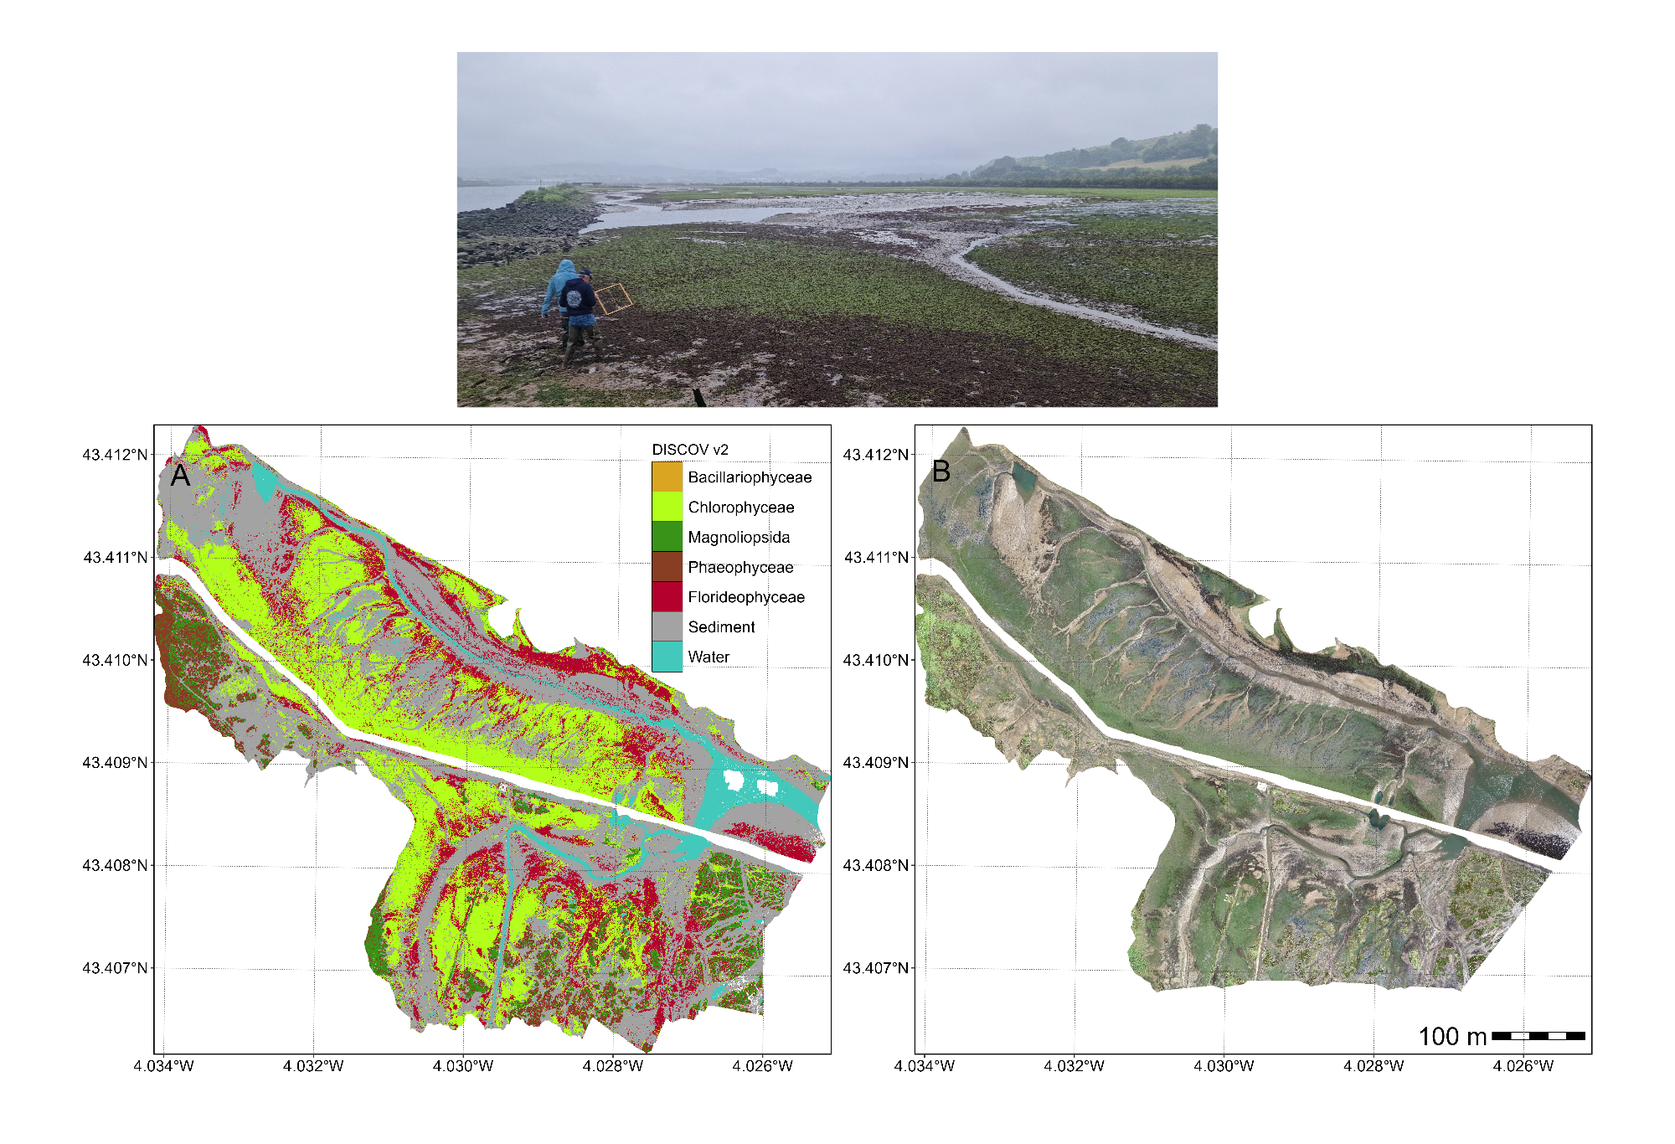
Figure 9: DISCOV Prediction (A), RGB composition (B) and picture of the field campaign of the Saja esturay, Nothern Spain. The total extent of this flight was 20.4 hectars with a resolution of 8 mm per pixel.

7. References

Abreu, M.H., Pereira, R., Buschmann, A., Sousa-Pinto, I., Yarish, C., 2011. Nitrogen uptake responses of Gracilaria vermiculophylla (ohmi) papenfuss under combined and single addition of nitrate and ammonium. Journal of Experimental Marine Biology and Ecology 407, 190–199.
Agisoft, 2019. Agisoft metashape.
Arim, M., Abades, S.R., Neill, P.E., Lima, M., Marquet, P.A., 2006. Spread dynamics of invasive species. Proceedings of the National Academy of Sciences 103, 374–378.
BenDor, T.K., Metcalf, S.S., 2006. The spatial dynamics of invasive species spread. System Dynamics Review: The Journal of the System Dynamics Society 22, 27–50.
Besterman, A.F., McGlathery, K.J., Reidenbach, M.A., Wiberg, P.L., Pace, M.L., 2021. Predicting benthic macroalgal abundance in shallow coastal lagoons from geomorphology and hydrologic flow patterns. Limnology and Oceanography 66, 123–140.
Blanchet, H., Gouillieux, B., Alizier, S., others, 2014. Multiscale patterns in the diversity and organization of benthic intertidal fauna among french atlantic estuaries. Journal of Sea Research 90, 95–110. https://doi.org/10.1016/j.seares.2014.02.014
Brunier, G., Tamura, T., Anthony, E.J., Dussouillez, P., Gardel, A., 2022. Evolution of the french guiana coast from late pleistocene to holocene based on chenier and beach sand dating. Regional Environmental Change 22, 122.
Bürkner, P.-C., 2021. Bayesian item response modeling in R with brms and Stan. Journal of Statistical Software 100, 1–54. https://doi.org/10.18637/jss.v100.i05
Bürkner, P.-C., 2018. Advanced Bayesian multilevel modeling with the R package brms. The R Journal 10, 395–411. https://doi.org/10.32614/RJ-2018-017
Bürkner, P.-C., 2017. brms: An R package for Bayesian multilevel models using Stan. Journal of Statistical Software 80, 1–28. https://doi.org/10.18637/jss.v080.i01
Byers, J.E., Gribben, P.E., Yeager, C., Sotka, E.E., 2012. Impacts of an abundant introduced ecosystem engineer within mudflats of the southeastern US coast. Biological invasions 14, 2587–2600.
Calleja, F., Galván, C., Silió-Calzada, A., Juanes, J.A., Ondiviela, B., 2017. Long-term analysis of Zostera noltei: A retrospective approach for understanding seagrasses’ dynamics. Marine environmental research 130, 93–105.
Castaing, P., Guilcher, A., 1995. Morphosedimentary evolution of ria-type estuaries. Earth Surface Processes and Landforms 20, 361–376. https://doi.org/10.1002/esp.3290200408
Chadwick, K.D., Brodrick, P.G., Grant, K., Goulden, T., Henderson, A., Falco, N., Wainwright, H., Williams, K.H., Bill, M., Breckheimer, I., others, 2020. Integrating airborne remote sensing and field campaigns for ecology and earth system science. Methods in Ecology and Evolution 11, 1492–1508.
Chand, S., Bollard, B., 2021. Low altitude spatial assessment and monitoring of intertidal seagrass meadows beyond the visible spectrum using a remotely piloted aircraft system. Estuarine, Coastal and Shelf Science 255, 107299.
Chang, W., Cheng, J., Allaire, J., Sievert, C., Schloerke, B., Xie, Y., Allen, J., McPherson, J., Dipert, A., Borges, B., 2024. Shiny: Web application framework for r.
Crowl, T.A., Crist, T.O., Parmenter, R.R., Belovsky, G., Lugo, A.E., 2008. The spread of invasive species and infectious disease as drivers of ecosystem change. Frontiers in Ecology and the Environment 6, 238–246.
Davies, B.F.R., Gernez, P., Geraud, A., Oiry, S., Rosa, P., Zoffoli, M.L., Barillé, L., 2023. Multi-and hyperspectral classification of soft-bottom intertidal vegetation using a spectral library for coastal biodiversity remote sensing. Remote Sensing of Environment 290, 113554.
Davies, B.F.R., Oiry, S., Rosa, P., Zoffoli, M.L., Sousa, A.I., Thomas, O.R., Smale, D.A., Austen, M.C., Biermann, L., Attrill, M.J., others, 2024b. A sentinel watching over inter-tidal seagrass phenology across western europe and north africa. Communications Earth & Environment 5, 382.
Davies, B.F.R., Oiry, S., Rosa, P., Zoffoli, M.L., Sousa, A.I., Thomas, O.R., Smale, D.A., Austen, M.C., Biermann, L., Attrill, M.J., others, 2024a. Intertidal seagrass extent from sentinel-2 time-series show distinct trajectories in western europe. Remote Sensing of Environment 312, 114340.
Davoult, D., Surget, G., Stiger-Pouvreau, V., Noisette, F., Riera, P., Stagnol, D., Androuin, T., Poupart, N., 2017. Multiple effects of a Gracilaria vermiculophylla invasion on estuarine mudflat functioning and diversity. Marine Environmental Research 131, 227–235.
Diruit, W., Le Bris, A., Bajjouk, T., Richier, S., Helias, M., Burel, T., Lennon, M., Guyot, A., Ar Gall, E., 2022. Seaweed habitats on the shore: Characterization through hyperspectral UAV imagery and field sampling. Remote Sensing 14. https://doi.org/10.3390/rs14133124
Douay, F., Verpoorter, C., Duong, G., Spilmont, N., Gevaert, F., 2022. New hyperspectral procedure to discriminate intertidal macroalgae. Remote Sensing 14. https://doi.org/10.3390/rs14020346
Douglas, T.J., Coops, N.C., Drever, M.C., Hunt, B.P., Martin, T.G., 2024. Linking microphytobenthos distribution and mudflat geomorphology under varying sedimentary regimes using unoccupied aerial vehicle (UAV)-acquired multispectral reflectance and photogrammetry. Science of The Total Environment 173675.
Duffy, J.P., Pratt, L., Anderson, K., Land, P.E., Shutler, J.D., 2018. Spatial assessment of intertidal seagrass meadows using optical imaging systems and a lightweight drone. Estuarine, Coastal and Shelf Science 200, 169–180.
Elton, C.S., 2020. The ecology of invasions by animals and plants. Springer Nature.
Firth, L.B., Foggo, A., Watts, T., Knights, A.M., DeAmicis, S., 2024. Invasive macroalgae in native seagrass beds: Vectors of spread and impacts. Annals of Botany 133, 41–50.
Gallardo, B., Clavero, M., Sánchez, M.I., Vilà, M., 2016. Global ecological impacts of invasive species in aquatic ecosystems. Global change biology 22, 151–163.
Ginneken, V. van, Vries, E. de, others, 2018. The global dispersal of the non-endemic invasive red alga Gracilaria vermiculophylla in the ecosystems of the euro-asia coastal waters including the wadden sea unesco world heritage coastal area: Awful or awesome? Oceanography & Fisheries Open Access Journal 8, 4–26.
Green, S.J., Grosholz, E.D., 2021. Functional eradication as a framework for invasive species control. Frontiers in Ecology and the Environment 19, 98–107.
Grizel, H., Heral, M., 1991. Introduction into france of the Japanese oyster (Crassostrea gigas). ICES Journal of Marine Science 47, 399–403.
Gurgel, C.F.D., Norris, J.N., Schmidt, W.E., Le, H.N., Fredericq, S., 2018. Systematics of the Gracilariales (Rhodophyta) including new subfamilies, tribes, subgenera, and two new genera, Agarophyton gen. nov. and Crassa gen. nov. Phytotaxa 374, 1–23.
Hijmans, R.J., 2024. Terra: Spatial data analysis.
Hu, Z.-M., Juan, L.-B., 2014. Adaptation mechanisms and ecological consequences of seaweed invasions: A review case of agarophyte gracilaria vermiculophylla. Biological invasions 16, 967–976.
IGN, 2024. Remonter le temps.
Jones, P.E., Tummers, J.S., Galib, S.M., Woodford, D.J., Hume, J.B., Silva, L.G., Braga, R.R., Garcia de Leaniz, C., Vitule, J.R., Herder, J.E., others, 2021. The use of barriers to limit the spread of aquatic invasive animal species: A global review. Frontiers in Ecology and Evolution 9, 611631.
Kollars, N.M., Byers, J.E., Sotka, E.E., 2016. Invasive décor: An association between a native decorator worm and a non-native seaweed can be mutualistic. Marine ecology progress series 545, 135–145.
Krueger-Hadfield, S., 2018. Everywhere you look, everywhere you go, there’s an estuary invaded by the red seaweed gracilaria vermiculophylla (ohmi) papenfuss, 1967. BioInvasions Records 7.
Krueger-Hadfield, S.A., Kollars, N.M., Strand, A.E., Byers, J.E., Shainker, S.J., Terada, R., Greig, T.W., Hammann, M., Murray, D.C., Weinberger, F., others, 2017. Genetic identification of source and likely vector of a widespread marine invader. Ecology and evolution 7, 4432–4447.
Krueger-Hadfield, S.A., Oetterer, A.P., Lees, L.E., Hoffman, J.M., Sotka, E.E., Murren, C.J., 2023. Phenology and thallus size in a non-native population of gracilaria vermiculophylla. Journal of Phycology 59, 926–938.
Loos, L.M. van der, Bafort, Q., Bosch, S., Ballesteros, E., Bárbara, I., Berecibar, E., Blanfuné, A., Bogaert, K., Bouckenooghe, S., Boudouresque, C.-F., others, 2024. Non-indigenous seaweeds in the Northeast Atlantic Ocean, the Mediterranean Sea and Macaronesia: A critical synthesis of diversity, spatial and temporal patterns. European Journal of Phycology 59, 127–156.
Massé, C., Viard, F., Humbert, S., Antajan, E., Auby, I., Bachelet, G., Bernard, G., Bouchet, V.M.P., Burel, T., Dauvin, J.-C., Delegrange, A., Derrien-Courtel, S., Droual, G., Gouillieux, B., Goulletquer, P., Guérin, L., Janson, A.-L., Jourde, J., Labrune, C., Lavesque, N., Leclerc, J.-C., Le Duff, M., Le Garrec, V., Noël, P., Nowaczyk, A., Pergent-Martini, C., Pezy, J.-P., Raoux, A., Raybaud, V., Ruitton, S., Sauriau, P.-G., Spilmont, N., Thibault, D., Vincent, D., Curd, A., 2023. An overview of marine non-indigenous species found in three contrasting biogeographic metropolitan French regions: Insights on distribution, origins and pathways of introduction. Diversity 15. https://doi.org/10.3390/d15020161
Mcilwaine, B., Casado, M.R., Leinster, P., 2019. Using 1st derivative reflectance signatures within a remote sensing framework to identify macroalgae in marine environments. Remote Sensing 11. https://doi.org/10.3390/rs11060704
Michel, G., Le Bot, S., Lesourd, S., Lafite, R., 2021. Morpho-sedimentological and dynamic patterns in a ria type estuary: The Belon estuary (South Brittany, France). Journal of Maps 17, 389–400. https://doi.org/10.1080/17445647.2021.1925170
Mudd, S.M., D’Alpaos, A., Morris, J.T., 2010. How does vegetation affect sedimentation on tidal marshes? Investigating particle capture and hydrodynamic controls on biologically mediated sedimentation. Journal of Geophysical Research: Earth Surface 115.
Nyberg, C.D., 2007. Introduced marine macroalgae and habitat modifiers: Their ecological role and significant attributes. Department of Marine Ecology.
Nyberg, C.D., Thomsen, M.S., Wallentinus, I., 2009. Flora and fauna associated with the introduced red alga Gracilaria vermiculophylla. European Journal of Phycology 44, 395–403.
Ohmi, H., 1956. Contributions to the knowledge of Gracilariaceae from Japan: Ⅱ. On a new species of the genus Gracilariopsis, with some considerations on its ecology. 北海道大學水産學部研究彙報 6, 271–279.
Oiry, S., 2024. Shiny app for validation dataset building.
Oiry, S., Davies, B.F.R., Sousa, A.I., Rosa, P., Zoffoli, M.L., Brunier, G., Gernez, P., Barillé, L., 2024. Discriminating seagrasses from green macroalgae in European intertidal areas using high-resolution multispectral drone imagery. Remote Sensing 16. https://doi.org/10.3390/rs16234383
Olmedo-Masat, O.M., Raffo, M.P., Rodrı́guez-Pérez, D., Arijón, M., Sánchez-Carnero, N., 2020. How far can we classify macroalgae remotely? An example using a new spectral library of species from the South West Atlantic (Argentine Patagonia). Remote Sensing 12, 3870.
Ortega, T., Ponce, R., Forja, J., Gómez-Parra, A., 2005. Fluxes of dissolved inorganic carbon in three estuarine systems of the cantabrian sea (north of spain). Journal of Marine Systems 53, 125–142.
Papenfuss, G.F., 1967. Notes on algal nomenclature - v. Various Chlorophyceae and Rhodophyceae. Phykos 5, 95–105.
Peidro-Devesa, M.J., Martı́nez-Movilla, A., Rodrı́guez-Somoza, J.L., Sánchez, J.M., Román, M., 2024. Quantifying intertidal macroalgae stocks in the NW iberian peninsula using unmanned aerial vehicle (UAV) multispectral imagery. Regional Studies in Marine Science 103621.
Raikar, S., Iima, M., Fujita, Y., 2001. Effect of temperature, salinity and light intensity on the growth of Gracilaria spp.(Gracilariales, Rhodophyta) from Japan, Malaysia and India.
Ramus, A.P., Silliman, B.R., Thomsen, M.S., Long, Z.T., 2017. An invasive foundation species enhances multifunctionality in a coastal ecosystem. Proceedings of the national academy of sciences 114, 8580–8585.
Roca, M., Dunbar, M.B., Román, A., Caballero, I., Zoffoli, M.L., Gernez, P., Navarro, G., 2022. Monitoring the marine invasive alien species Rugulopteryx okamurae using unmanned aerial vehicles and satellites. Frontiers in Marine Science 9, 1004012.
Román, A., Oiry, S., Davies, B.F., Rosa, P., Gernez, P., Tovar-Sánchez, A., Navarro, G., Méléder, V., Barillé, L., 2024. Mapping intertidal microphytobenthic biomass with very high-resolution remote sensing imagery in an estuarine system. Science of The Total Environment 177025.
Román, A., Tovar-Sánchez, A., Olivé, I., Navarro, G., 2021. Using a UAV-mounted multispectral camera for the monitoring of marine macrophytes. Frontiers in Marine Science 8, 722698.
Romero, M., Andrés, A., Alonso, R., Viguri, J., Rincón, J.M., 2008. Sintering behaviour of ceramic bodies from contaminated marine sediments. Ceramics International 34, 1917–1924.
Ross, P.G., Snyder, R.A., 2022. Ecological monitoring program at VIMS ESL: Annual report 2021.
Rueness, J., 2005. Life history and molecular sequences of Gracilaria vermiculophylla (Gracilariales, Rhodophyta), a new introduction to European waters. Phycologia 44, 120–128.
Savitzky, A., Golay, M.J., 1964. Smoothing and differentiation of data by simplified least squares procedures. Analytical chemistry 36, 1627–1639.
Sfriso, A., Wolf, M.A., Maistro, S., Sciuto, K., Moro, I., 2012. Spreading and autoecology of the invasive species Gracilaria vermiculophylla (Gracilariales, Rhodophyta) in the lagoons of the North-Western Adriatic Sea (Mediterranean Sea, Italy). Estuarine, Coastal and Shelf Science 114, 192–198.
Simberloff, D., 2021. Maintenance management and eradication of established aquatic invaders. Hydrobiologia 848, 2399–2420.
Sotka, E.E., Baumgardner, A.W., Bippus, P.M., Destombe, C., Duermit, E.A., Endo, H., Flanagan, B.A., Kamiya, M., Lees, L.E., Murren, C.J., others, 2018. Combining niche shift and population genetic analyses predicts rapid phenotypic evolution during invasion. Evolutionary Applications 11, 781–793.
Stiger-Pouvreau, V., Thouzeau, G., 2015. Marine species introduced on the French Channel-Atlantic coasts: A review of main biological invasions and impacts. Open Journal of Ecology 5, 56784.
Surget, G., 2017. Processus adaptatifs des végétaux marins face au changement climatique à différentes échelles de temps et d’espace: Dynamique de populations, métabolomique, écophysiologie et potentiels de valorisation (PhD thesis). Université de Bretagne occidentale-Brest.
Surget, G., Le Lann, K., Delebecq, G., Kervarec, N., Donval, A., Poullaouec, M.-A., Bihannic, I., Poupart, N., Stiger-Pouvreau, V., 2017. Seasonal phenology and metabolomics of the introduced red macroalga Gracilaria vermiculophylla, monitored in the Bay of Brest (France). Journal of Applied Phycology 29, 2651–2666.
Tankoua, O.F., Buffet, P.-E., Amiard, J.-C., Amiard-Triquet, C., Mouneyrac, C., Berthet, B., 2011. Potential influence of confounding factors (size, salinity) on biomarkers in the sentinel species Scrobicularia plana used in programmes monitoring estuarine quality. Environmental Science and Pollution Research 18, 1253–1263. https://doi.org/10.1007/s11356-011-0479-3
Terada, R., Yamamoto, H., 2002. Review of Gracilaria vermiculophylla (Ohmi) papenfuss and other species in Japan and Asia. Taxonomy of economic seaweeds, with special reference to Pacific species 8, 225–230.
Thomsen, M., McGlathery, K.J., 2007. Stress tolerance of the invasive macroalgae Codium fragile and Gracilaria vermiculophylla in a soft-bottom turbid lagoon. Biological invasions 9, 499–513.
Thomsen, M.S., 2010. Experimental evidence for positive effects of invasive seaweed on native invertebrates via habitat-formation in a seagrass bed. Aquatic Invasions 5, 341–346.
Thomsen, M.S., McGlathery, K., Schwarzschild, A., Silliman, B., 2009. Distribution and ecological role of the non-native macroalga Gracilaria vermiculophylla in Virginia salt marshes. Biological Invasions 11, 2303–2316.
Thomsen, M.S., Staehr, P.A., Nyberg, C.D., Schwærter, S., Krause-Jensen, D., Silliman, B.R., 2007. Gracilaria vermiculophylla (ohmi) papenfuss, 1967 (rhodophyta, gracilariaceae) in northern europe, with emphasis on danish conditions, and what to expect in the future. Aquatic invasions 2, 83–94.
Thomsen, M.S., Stæhr, P.A., Nejrup, L., Schiel, D.R., 2013. Effects of the invasive macroalgae gracilaria vermiculophylla on two co-occurring foundation species and associated invertebrates. Aquatic Invasions 8, 133–145.
Valle, M., Pala, V., Lafon, V., Dehouck, A., Garmendia, J.M., Borja, A., Chust, G., 2015. Mapping estuarine habitats using airborne hyperspectral imagery, with special focus on seagrass meadows. Estuarine, Coastal and Shelf Science 164, 433–442.
Van Katwijk, M., 2003. Reintroduction of eelgrass (zostera marina l.) in the dutch wadden sea: A research overview and management vision, in: Challenges to the Wadden Sea Area. In: Proceedings of the 10th International Scientific Wadden Sea Symposium, Groningen, the Netherlands. pp. 173–195.
Weinberger, F., Buchholz, B., Karez, R., Wahl, M., 2008. The invasive red alga Gracilaria vermiculophylla in the Baltic Sea: Adaptation to brackish water may compensate for light limitation. Aquatic Biology 3, 251–264.
Williams, S.L., Smith, J.E., 2007. A global review of the distribution, taxonomy, and impacts of introduced seaweeds. Annu. Rev. Ecol. Evol. Syst. 38, 327–359.
Zenetos, A., Tsiamis, K., Galanidi, M., Carvalho, N., Bartilotti, C., Canning-Clode, J., Castriota, L., Chainho, P., Comas-González, R., Costa, A.C., Dragičević, B., Dulčić, J., Faasse, M., Florin, A.-B., Gittenberger, A., Jakobsen, H., Jelmert, A., Kerckhof, F., Lehtiniemi, M., Livi, S., Lundgreen, K., Macic, V., Massé, C., Mavrič, B., Naddafi, R., Orlando-Bonaca, M., Petovic, S., Png-Gonzalez, L., Carbonell Quetglas, A., Ribeiro, R.S., Cidade, T., Smolders, S., Stæhr, P.A.U., Viard, F., Outinen, O., 2022. Status and trends in the rate of introduction of marine non-indigenous species in european seas. Diversity 14. https://doi.org/10.3390/d14121077
Zoffoli, M.L., Gernez, P., Godet, L., Peters, S., Oiry, S., Barillé, L., 2021. Decadal increase in the ecological status of a north-atlantic intertidal seagrass meadow observed with multi-mission satellite time-series. Ecological Indicators 130, 108033.
Zoffoli, M.L., Gernez, P., Oiry, S., Godet, L., Dalloyau, S., Davies, B.F.R., Barillé, L., 2023. Remote sensing in seagrass ecology: Coupled dynamics between migratory herbivorous birds and intertidal meadows observed by satellite during four decades. Remote Sensing in Ecology and Conservation 9, 420–433.

Institut des Substances et Organismes de la Mer, ISOMer, Nantes Université, UR 2160, F-44000 Nantes, France
Univ Brest, Institut de Recherche pour le Développement (IRD), CNRS, Ifremer, LEMAR, IUEM, F-29280 Plouzane, France

